Static, 1

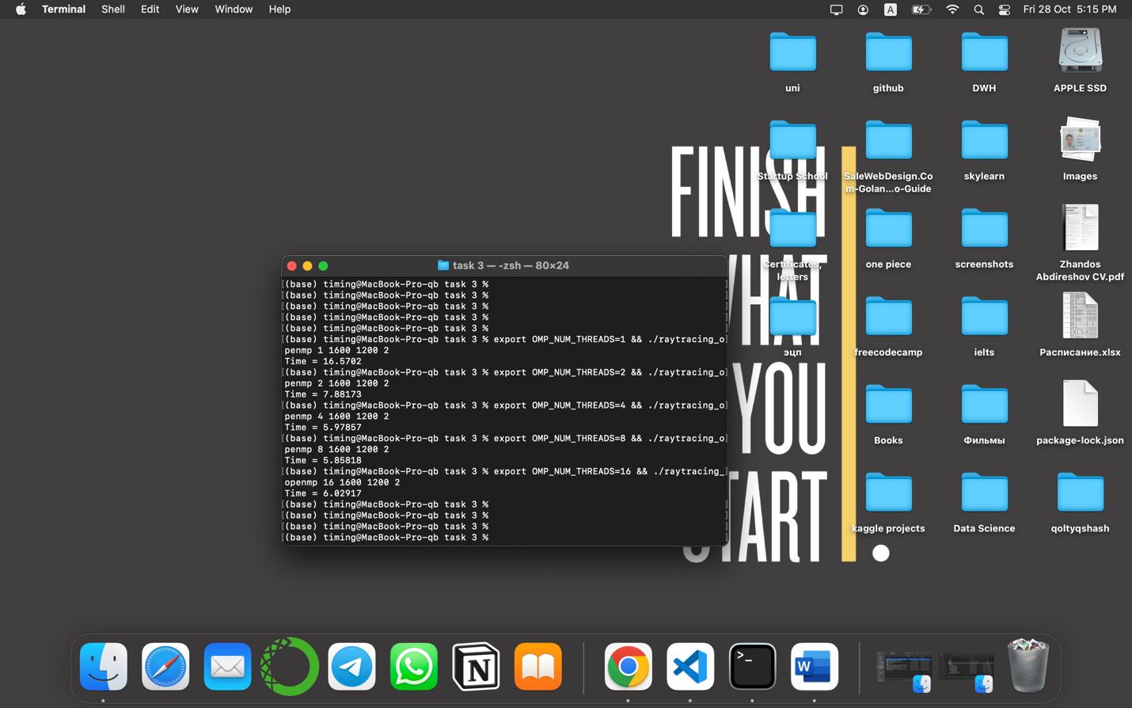

Static

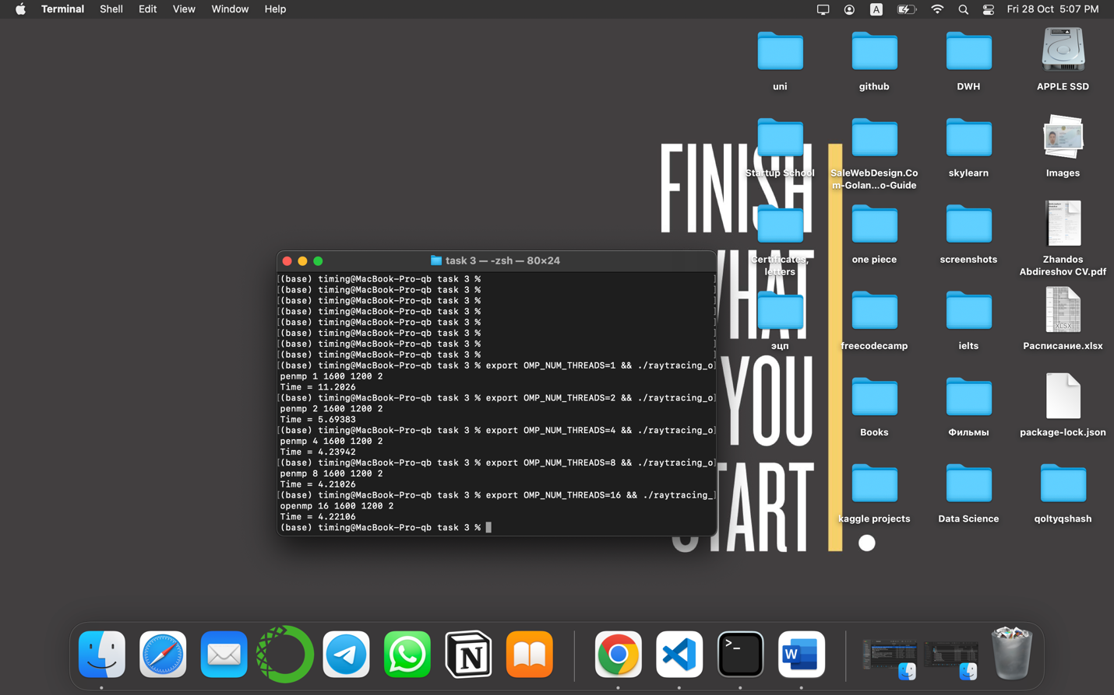

Dynamic

Table

1. Speedup: Speedup(N) = Time(1) / Time(N), N - number of threads
2. Efficiency: Efficiency(N) = Speedup(N) / N

|  |  |  |  |  |  |  |  |  |  |
| --- | --- | --- | --- | --- | --- | --- | --- | --- | --- |
| Threads | Dynamic |  |  | Static |  |  | Static,1 |  |  |
|  | Time | Speed | Efficiency | Time | Speed | Efficiency | Time | Speed | Efficiency |
| 1 | 11.4213 | 1 | 1 | 11.2026 | 1 | 1 | 16.5702 | 1 | 1 |
| 2 | 5.63605 | 2.02 | 1.01 | 5.69383 | 1.96 | 0.98 | 7.88173 | 2.1 | 1.05 |
| 4 | 4.23073 | 2.69 | 0.67 | 4.23942 | 2.64 | 0.66 | 5.97857 | 2.77 | 0.69 |
| 8 | 4.21381 | 2.71 | 0.33 | 4.21026 | 2.66 | 0.33 | 5.85818 | 2.82 | 0.35 |
| 16 | 4.23365 | 2.69 | 0.16 | 4.22106 | 2.65 | 0.16 | 6.02917 | 2.74 | 0.17 |

Conclusion

According to the table, static,1 displays best result, but they are +- do not differ from each other. Dynamic shows better results on threads = 1,2,4 rather than static, and in 8,16 threads they are similar.